Computer Security Assignment 2

Student: Dan Popoutanu

Date: 20.12.2017

Task 1
The first task was generating two private-keys in the range 0 to 500 using the combined linear congruential generator. With the given values for m1,a1,m2,a2 this task was just some basic python coding. Based on the formula from the lessons and the given values we return a Rand function that we call 2 times so we get two different values.
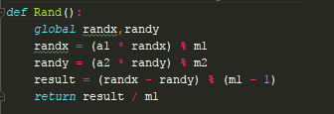

Task 2
Once we have the two values previously generated using the Diffie-Hellman algorithm we get the secret key. First we calculate the two public keys for our two users and then we calculate the secret key by raising ones public key to the power of the others private key modulo q.
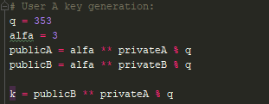

Task 3
The fun part. The rc4 algorithm starts out with initialization of S and Stream Generation which is by the book. The encrypt logic function that follows starts out with getting the secret key previously made where we remove the dot ( key example “1.12389123123354”) so that our encrypting doesn’t get up an error. Then for each key element we Xor with each ASCII value of the text and format it as hexcode. We append everything to an array which we turn into a string of values. 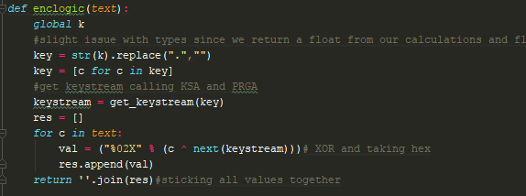
To keep a clean code we have a new function for encrypting and one for decrypting that each call our previous function.
Finally we open a text file in python from which we take the last 128 contents using the slice method [-128:], we encrypt the text and save it to a new file.

Task 4
Decrypting is based a lot on the codec registry and base classes from python, that is why in the beginning of the exercise we import codecs to our file. The decryption is taking the values from our encrypted file turning it into bytes and running it through our encryptlogic function from which we call our codecs decode again to transform it into utf-8.

Example: Encrypting : “ Computer science”
The key automatically generated is : “ 1.0005047222402144
The cipher text in this case is : 436F6D707574657220736369656E6365

